**Module 10 term project**

I worked with chemicals in cosmetics data to predict which cosmetics were discontinued. I plotted the ROC graph and got an AUC value for if the cosmetics were discontinued true (based on naïve bayes predictions). Below is the screenshot of the code I used.

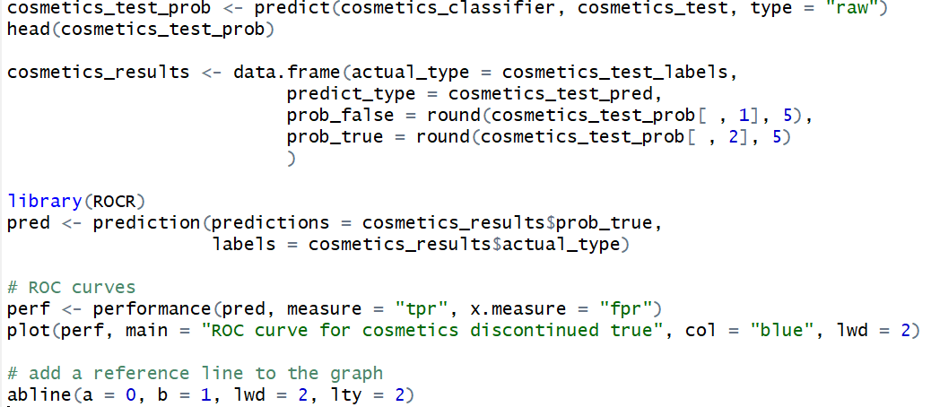

This is the ROC graph. It looks pretty good as it is quite far from the chance line (dotted line).

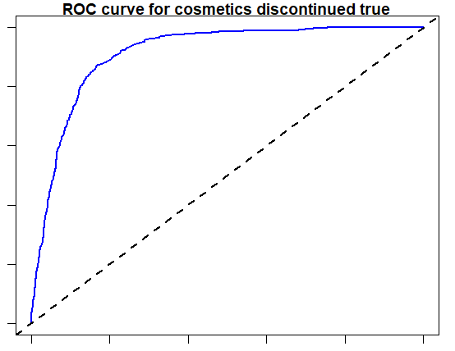

The AUC value was 0.91 which is generally considered outstanding so it seems like the naïve bayes model is working quite well after all.